Introduction to Boolean-based Multi-Secret Image Sharing Schemes
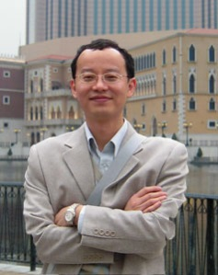
Chien-Chang Chen received the B.S. degree from Department of Computer and Information Science at Tunghai University, Taiwan, in 1991, and the Ph.D. degree from Department of Computer Science at National Tsing Hua University, Taiwan, in 1999. He is currently an Associate Professor at the Department of Computer Science and Information Engineering, Tamkang University, Taiwan. His research interests include secret image sharing, watermarking, and texture analysis.

